# **Winterborne Houghton Parish Council**

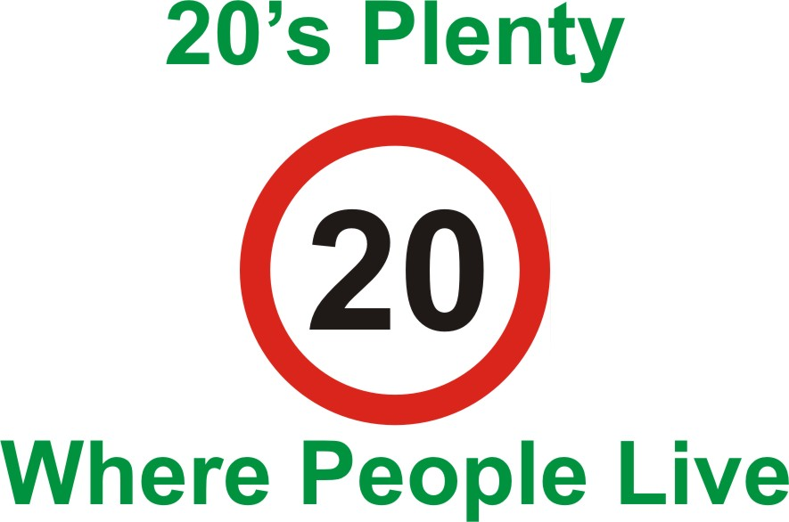

## **Application for a 20 mph speed limit through the village**

One of the major issues raised by residents has been the problem of excessive speed through the village. Most of us have encountered incidents where a serious accident with a speeding vehicle has only just been avoided. With the increase in traffic, peoples busy life styles, our lack of pavements and passing places there is a significant risk of an accident unless we take action.

Why 20 mph? Research has shown that by introducing a 20 mph speed limit the danger to walkers and cyclists is reduced by a staggering 95%! **The Dept for Transport guidance on setting local speed limits was revised in 2013 and this very much encourages the use of 20mph limits or zones for residential streets and those with high numbers (or potential numbers) of cyclists and pedestrians.**

Look at the stopping distances at different speeds. The stopping distance at 20 mph is approximately half that at 30 mph. More time to avoid that child, cyclist, dog walker or resident out for a stroll or going to the post.

The Parish Council can take advantage of **“20 is Plenty for Us”** who are the national organisation campaigning for 20 mph default speed limits, without traffic calming, where people live. For more information on their campaign visit <http://www.20splentyforus.org.uk/campaigning.htm>. What happens next? Shortly after receiving this leaflet you will see signs going up in the village promoting our campaign. They will be placed on the proposed boundaries of the limit and by the phone box. **During the the week commencing 23 March your household will be visited by a member or representative of the parish council and asked to sign a petition supporting the introduction of the speed limit. They should be able to answer any questions that you may have. The petition will be presented to the appropriate person within the North Dorset District Council requesting the implementation of a 20 mph speed limit. Updates on the campaign will be found in the Valley News and posted on the village website http://www.winterbornehoughton.org.uk/**

**Without the support of the village our campaign will not succeed!**

A speed limit alone will not make our village safer but will give us the opportunity to take part in the police initiative **‘speed watch’** where residents can record vehicle speeds with the support of the police and enforcement action can be taken as necessary. At the moment as the speed limit through Houghton is **60** **mph** no action can be taken to slow traffic down.

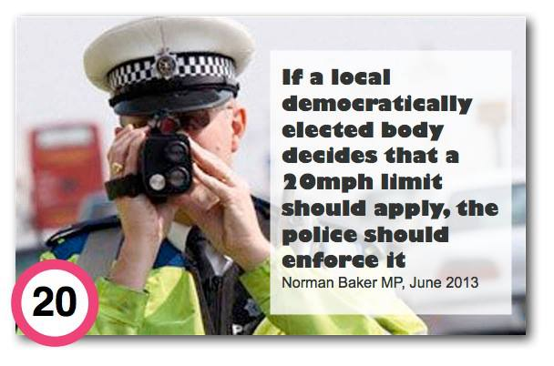

A map of the proposed 20 mph limit is shown overleaf. If you have any questions please feel free to contact any members of the parish council or Sam Smith, the Parish Clerk

[**email: winterbornehoughton@dorset**](mailto:email: winterbornehoughton@dorset)**-aptc.gov.uk**